What Is Chap Research

Chap Research is an after school “innovation program” that gives Westlake High School students the opportunity to learn real-world technical, research, leadership, and entrepreneurial skills not otherwise taught in school.

***Our First Patent***

Three student members of Chap Research have just been granted a patent for their work on “The ChapR”.



Chap Research was created to provide students with an opportunity to experience and participate in research and design, giving them the experience and confidence to succeed in college and career settings. Through our relationships with industry mentors, Chap Research brings real-world issues and challenges to the students and helps them discover and implement innovative solutions to problems.

Chap Research also helps prepare students for college applications, providing opportunities to specialize in their particular interests to show college admissions their dedication and passion. Many of the projects in Chap Research provide opportunities to build the student’s “digital portfolio”, highlighting their successes and innovative skills as they pursue patents, publications or news coverage for their work.

Apply Now!

Students who are selected for Chap Research are dedicated and focused, and can work within a team of other highly intelligent students working toward a goal. A minimum of seven hours per week is required to be a member of the Chap Research team. Members must have a passion and drive for discovery and the ***completion*** of projects.



If you want to be part of the innovation, scan the QR code to fill out the application!

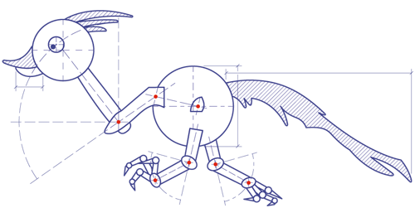

Some Chap Research Projects

|  |  |
| --- | --- |
| thechapr.png | ***The ChapR***  The ChapR is a patented remote for controlling FTC, FLL, and FRC robots without a PC. It allows teams to easily set up drive practices and run autonomous programs without bothering the programmer(s) or fighting over the few PCs available. |
|  | ***Order Entry & Processing System***  Through custom PHP, SQL, and Wordpress on a Linux host, the order entry system processes incoming ChapR orders. Through integration with Paypal, incoming payments are processed and shipments are made. |
| https://www.digilentinc.com/Data/Products/MXP-WW/MXP-WW-obl-600.png | ***The BeatBoard (a RoboRIO Expansion Board)***  Designed to separate sound into its frequency bands, this board allows robots to act upon music, flashing lights and moving motors. |
| ***http://www.groupe-patus.fr/wp-content/uploads/2014/03/07-Beautiful-Fruit-Wallpapers.jpg***  **TEDx** | ***Fruit Spiral (a TEDx Project)***  The Fruit Spiral is a game platform using fruit as touch sensors that was exhibited at TEDx labs this past Valentine’s Day. A huge hit with all ages, it served as a way of showing what can be done with technology, as well as teaching students electronics, embedded programming and 3D printing. |

Our Sponsors

Chap Research is supported by Chap Robotics, and donations from the Westlake & Eanes Science & Technology Association.